19BCE226 - Ansh Ray

27/09/2022

**Practical 3**

HDFS COMMANDS USED IN THIS PRACTICAL:

1) jps: Used to check the Hadoop services are up and running

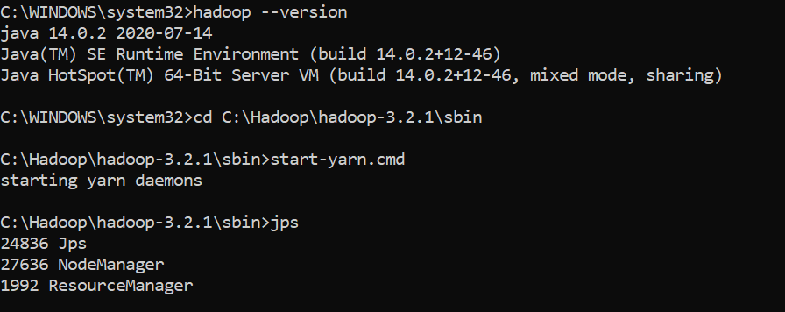

2) mkdir: Used to create a directory in a distributed file system.



3) ls: Used to list all the files.

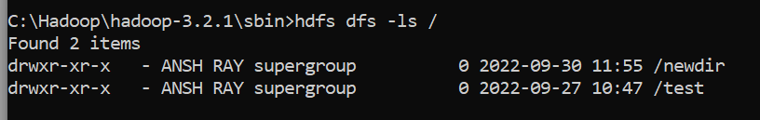

4) touchz: Used to create an empty file.

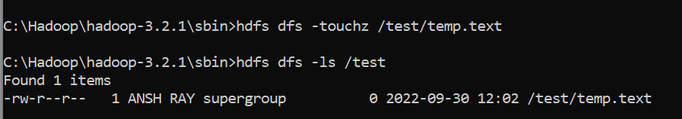

5) chmod: Used to change the permission of the file. Default value is 644 which means it gives read and write permissions to user, group and others.

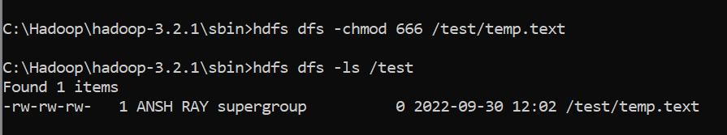

6) copyFromLocal: Used to copy files and folders from local file system to the distributed system

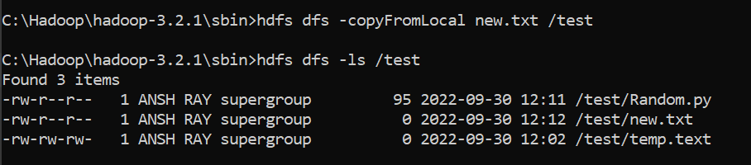

7) copyToLocal: Used to copy files/folders from distributed file system to local file system

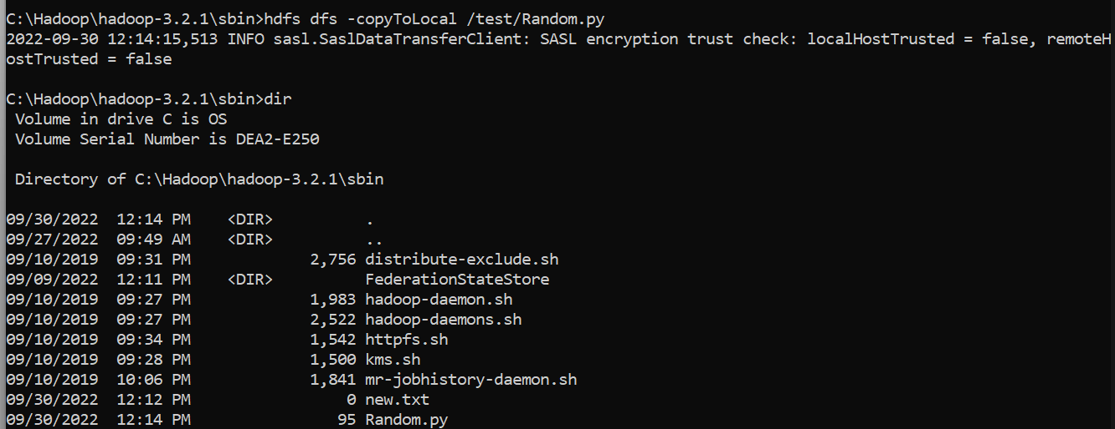

8) moveFromLocal : Used to move files from local to distributed file system

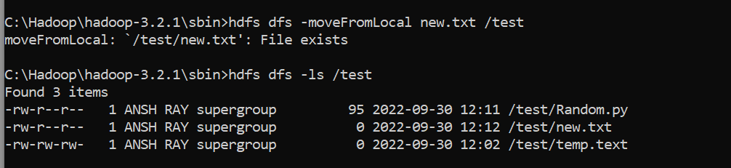

9) cp: Used to copy files in distributed file system.

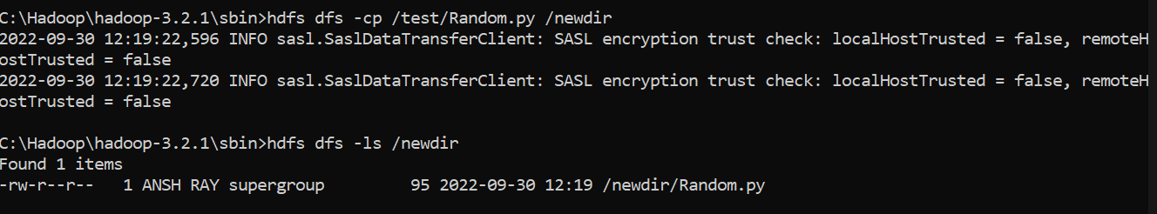

10) mv : Used to move files in distributed file system

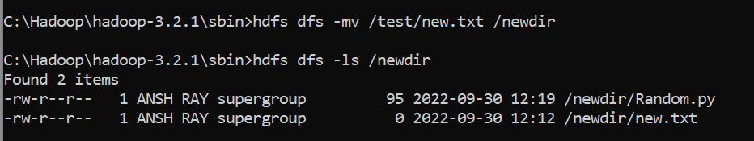

11) cat: Used to display content of the file

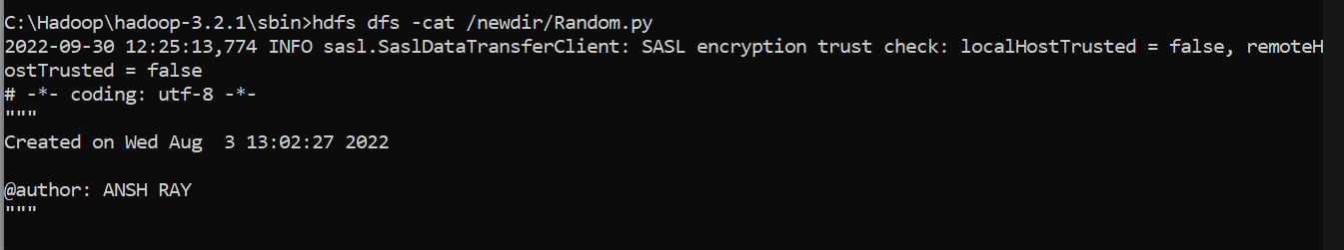

12) du: Used to display the size of each file in the directory.

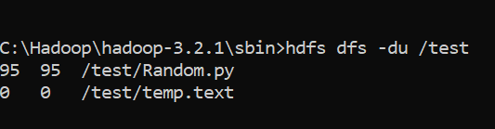

13) dus: Used to display the total size of the directory.

